1. What is a Constructive Trust?
A constructive trust is a legal concept developed by courts of equity to make individuals accountable in situations where it would be unjust for them to deny the beneficial interest of another person. A constructive trust arises automatically by operation of law, not because of the intent of the parties involved. This is described by Dal Pont in Equity and the Law of Trusts (6th Ed. 2015), as a means of attaching legal consequences to certain circumstances (Scott and Fratcher, The Law of Trusts, 4th Ed., Volume 5, Paragraph 462.4).
The term "constructive" derives from the Latin verb construere, meaning "to interpret" or "explain". Hence, the court does not construct a trust, but construes the facts and circumstances of a case, attaching equitable consequences to those facts. This differs from express trusts, where the trust is voluntarily created by the parties involved.

Key Cases and Legal Principles:
1. Giumelli v Giumelli (1999): Describes how courts impose a constructive trust as a consequence of unconscionable conduct.
2. Scott and Fratcher (4th Edition): Reinforces that a constructive trust arises from the circumstances as construed by the court, not from an act of construction.

2. What is a Fiduciary?
A fiduciary is an individual or entity that has a duty to act in the best interest of another party. Fiduciaries are in positions where they have authority or discretion over the interests or property of another and must act in absolute loyalty and without conflict of interest (Paul Finn, Fiduciary Obligations, 1977).

Key Fiduciary Duties:
Fiduciaries must not seek unauthorized benefits from the relationship or be in a conflict of interest. For example, in Aucare Dairy (Aust) Pty Ltd v Huang (2019), fiduciary obligations of company directors were analyzed, showing that directors must act in the company’s best interest and avoid personal gain at the company’s expense.
Proscriptive Duties:
1. No profit rule: A fiduciary must not profit from the relationship unless explicitly authorized.
2. No conflict rule: A fiduciary must not allow personal interests to conflict with their duty to the principal.

2. Institutional Constructive Trusts

Definition
An institutional constructive trust arises automatically by operation of law at the time of the events that give rise to it. Courts merely declare its existence and do not create it (Westdeutsche Landesbank Girozentrale v Islington LBC [1996] AC 669, at 714–716).

Key Characteristics
- Operates retrospectively from the time of the breach or the unconscionable action.
- Arises primarily from breaches of fiduciary duty, fraud, or theft.
- The property held under such a trust is considered trust property from the outset.

Key Cases
- Westdeutsche Landesbank Girozentrale v Islington LBC [1996]:
Lord Browne-Wilkinson: The trust arises automatically, retrospectively binding the conscience of the party holding the property.
- Black v S Freedman & Co [1910] HCA 58:
Stolen money was declared trust property in the thief's hands. This trust arises eo instanti (immediate) upon theft.
- UTi (Aust) Pty Ltd v Sheehan & Anor [2017] NSWSC 344:
Slattery J confirmed that stolen funds become subject to a trust as soon as the theft occurs.
- Sze Tu v Lowe [2014] NSWCA 462:
The trust arises automatically due to the misappropriation of partnership funds.
- Robb Evans v European Bank Ltd [2004] NSWCA 82:
Spigelman CJ characterized the trust arising from fraud as institutional rather than remedial.
- Taylor v Davies:
Distinguished institutional trusts as real property interests and remedial trusts as equitable relief tools.

Judicial Opinions
1. Lord Millett (Paragon Finance v Thakerar [1999]):
- Criticized the misleading terminology around constructive trusts, emphasizing the institutional nature of those arising from lawful transactions that later become unconscionable.
2. Slattery J (UTi case):
- Declared that institutional constructive trusts arise automatically upon misappropriation.

Scholarly Views
- Lewin on Trusts (19th Ed.):
Institutional constructive trusts arise independently of judicial declarations.
- Lord Neuberger (14 Aug 2014 at Queenstown, New Zealand):
Highlighted the clarity of institutional constructive trusts compared to the discretionary nature of remedial trusts.
- Professor Bryan (Ford & Lee):
Emphasized the automatic nature of institutional trusts in fiduciary breaches.

3. Remedial Constructive Trusts

Definition
A remedial constructive trust is created by the court’s discretion to address specific equitable wrongs. It does not exist until declared by the court.

Key Characteristics
- It arises post-facto as a remedy, not automatically.
- Often linked to equitable compensation or adjustments of proprietary rights.
- Criticized for its uncertainty and potential interference with property rights.

Key Cases
- Muschinski v Dodds (1985) 160 CLR 583:
Deane J characterized the remedial constructive trust as a discretionary remedy to prevent unjust enrichment.
- FHR European Ventures LLP v Cedar Capital Partners LLC [2015] AC 250:
Lord Neuberger explicitly stated that remedial constructive trusts are not recognized in English law.
- Polly Peck (No. 2) [1998] 3 All ER 812:
The court rejected remedial constructive trusts for their ability to reallocate proprietary rights arbitrarily.
- Paragon Finance v Thakerar [1999]:
Lord Millett described remedial trusts as "misleading" and "a catchphrase" rather than genuine trusts.

Judicial Opinions
1. Lord Millett (Paragon Finance v Thakerar):
Criticized remedial trusts for being imprecise and argued that they do not constitute actual trusts.
2. Lord Neuberger (FHR Ventures):
Dismissed the remedial constructive trust as alien to English legal traditions.

Scholarly Views
- Heydon J (2018):
Called remedial constructive trusts a "last resort" measure and warned against overuse.
- Lord Neuberger (2014, New Zealand Paper):
Criticized the vagueness of remedial trust tests, such as “justice in all circumstances.”

3. Differences Between Institutional and Remedial Trusts

Institutional Constructive Trusts:
Definition: These arise automatically from specific circumstances, such as fiduciary breaches, theft, or misappropriation of assets. The trust is recognized retroactively, from the moment the wrongful action occurs. Courts merely declare that the trust existed all along.

Key Characteristics:
- Automatic upon the wrongful action (theft, breach of fiduciary duty).
- Not discretionary; the trust exists by operation of law.
- Proprietary: Beneficiaries can trace the property back to the trust, even if it has been transferred to third parties (Black v S Freedman & Co [1910] HCA 58; Sze Tu v Lowe [2014] NSWCA 462).

Cases Involving Institutional Trusts:
- Black v S Freedman & Co (1910): Stolen funds automatically became trust property.
- Westdeutsche Landesbank Girozentrale v Islington LBC (1996): Lord Browne-Wilkinson emphasized that such a trust arises automatically, and the court merely recognizes it.
- UTi (Aust) Pty Ltd v Sheehan (2017): The court found that stolen funds automatically became the subject of an institutional constructive trust.
- Sze Tu v Lowe (2014): Emphasized that stolen or misappropriated property held by the wrongdoer is automatically subject to a constructive trust.

Remedial Constructive Trusts:
Definition: Imposed by the court’s discretion as a remedy for wrongs or unjust enrichment. It is not automatic and does not arise until a court declares it. It is used when equitable compensation or other remedies are inadequate.

Key Characteristics:
- Discretionary: The court determines if it is appropriate to impose the trust.
- Remedial: Often used to rectify wrongs or breaches, but it may not grant proprietary rights immediately, unlike institutional trusts.

Cases Involving Remedial Trusts:
- Muschinski v Dodds (1985): Deane J introduced the concept of the remedial constructive trust to remedy unconscionable conduct.
- Polly Peck (No. 2) (1998): The court rejected a remedial constructive trust, favoring other remedies instead.
- Paragon Finance v Thakerar (1999): Lord Millett criticized the remedial constructive trust as a “misleading formula.”
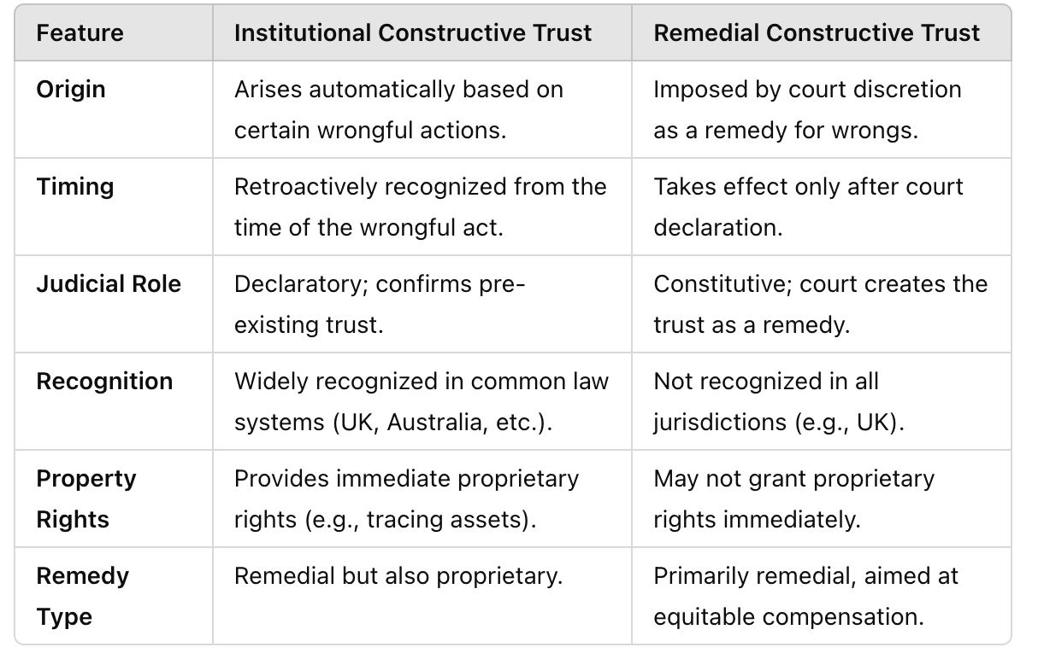

4. Operation and Recognition in Law

Institutional Constructive Trusts
1. Operate automatically in cases of:
- Fiduciary breaches (e.g., conflict or profit rules).
- Misappropriation of funds or theft (Black v S Freedman).
2. Fully recognized in English, Australian, and Canadian law.
3. Allows tracing of assets and provides secured creditor status.

Remedial Constructive Trusts
- Recognized in Australian law but not in English law.
- Used in cases like Muschinski v Dodds (Australia) to prevent unjust enrichment or address unconscionable conduct.
A remedial constructive trust serves as a tool to restore the benefit unjustly gained by the defendant, ensuring that the person who has been wronged is not left at a disadvantage simply because the wrongdoer has gained an advantage.
Equitable compensation alone (such as a monetary award) would not suffice to restore the property or benefit that was misappropriated or wrongfully retained. The remedial constructive trust is used to reallocate the property or asset itself, rather than just awarding compensation.
Equitable Compensation vs. Remedial Constructive Trust:
- Equitable compensation is generally monetary and is appropriate in cases where losses can be quantified (e.g., where a financial loss can be measured). However, when the wrong involves the misappropriation of property, equitable compensation might not fully restore the wronged party’s rights or ownership.
- The remedial constructive trust, on the other hand, provides a remedy in kind, ensuring that the wrongdoer holds the property for the benefit of the rightful owner. This remedy operates beyond mere compensation by ensuring the restitution of the property or benefit itself.

5. Key Points
1. Flexibility vs. Certainty:
Institutional trusts offer predictability; remedial trusts provide discretionary flexibility but risk unpredictability.
2. Unconscionability:
A key principle in both institutional and remedial trusts, though it is criticized for being vague. Both types rely on the principle that it would be unconscionable for the holder of legal title to deny another's beneficial interest (Lord Millett in Paragon Finance and FHR European Ventures).
3. Fiduciary Duties:
A breach of fiduciary duties, such as the no profit or no conflict rules, often gives rise to an institutional constructive trust. A fiduciary must act solely in the interest of the beneficiary without self-interest.
4. Tracing and Property Rights:
Institutional trusts allow the tracing of stolen or misappropriated property, creating proprietary rights for the beneficiary, while remedial trusts may not grant such rights immediately and are more flexible as a court-imposed remedy.
5. Judicial Criticism:
Remedial constructive trusts are often seen as flexible but flabby, with critics like Lord Neuberger calling them a “catchphrase” for equitable remedies rather than genuine trusts. However, institutional constructive trusts are seen as more predictable and rooted in clear legal principles.

